**Phase 1 Exam**

1)

create database finalevaluation;

go

use finalevaluation;

go

create table destination(destination_id int not null primary key,destination_name varchar(20))

create table covering(place_id int not null ,place_name varchar(20),destination_id int foreign key references destination(destination_id),primary key(place_id,destination_id));

create table plans(plan_id int not null primary key,plan_name varchar(20),destination_id int not null foreign key references destination(destination_id))

insert into destination(destination_id,destination_name)

values

(20,'Goa'),

(21,'Delhi'),

(22,'jammu');

insert into covering(place_id,place_name,destination_id)

values

(101,'plc1',20),

(102,'plc2',20),

(103,'plc3',21),

(104,'plc4',21),

(105,'plc5',22),

(106,'plc6',22),

(107,'plc7',22);

insert into plans(plan_id,plan_name,destination_id)

values(1234,'Goa trip',20),

(1235,'Delhi trip',21),

(1236,'Jammu plan',22);

create table Planperiod(

PeriodID int not null,

noofdays tinyint not null,

plan_id int foreign key references plans(plan_id),

primary key(PeriodID,plan_id));

insert into Planperiod(PeriodID,noofdays,plan_id)

values(2222,1,1235),

(2223,12,1235),

(2224,2,1236),

(2225,10,1236),

(2224,5,1234),

(2225,6,1234);

create table Transpordmode(

TID int not null,

Tname char(20),

plan_id int foreign key references plans(plan_id),

primary key(TID,plan_id));

insert into Transpordmode(TID,Tname,plan_id)

values(3333,'Bus',1234),

(3334,'Plain',1234),

(3335,'Train',1234),

(3336,'Bus',1235),

(3337,'Plain',1235),

(3338,'Train',1236);

create table Planprice(

PPID int not null,

amount int not null,

PeriodID int not null,

TID int not null,

plan_id int not null foreign key references plans(plan_id),

foreign key (PeriodID,plan_id) references Planperiod(PeriodID,plan_id),

foreign key (TID,plan_id) references Transpordmode(TID,plan_id),

primary key(PPID,PeriodID,TID,plan_id));

insert into Planprice(PPID,amount,PeriodID,TID,plan_id)

values(999,12000,2225,3334,1234),

(999,18000,2225,3335,1234)

update Transpordmode set Tname = 'car'

where TID =3337;

select plans.plan_name from plans join Transpordmode on plans.plan_id = Transpordmode.plan_id where Transpordmode.Tname = 'car';

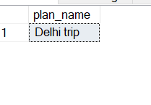

2)

select covering.place_name, destination_name from covering join destination on covering.destination_id = destination.destination_id;

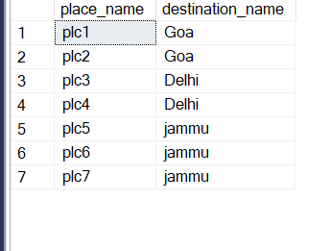

3)

select plans.plan_name,Planprice.amount from plans join Planprice on plans.plan_id =Planprice.plan_id order by Planprice.amount**;**

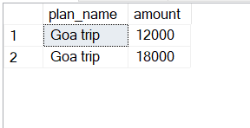

4) db.trip.insertMany([{"id":1,"plan":"goa","mode":"flight","days":5,"price":12000,"type":1},{"id":2,"plan":"goa","mode":"bus","days":8,"price":11000,"type":2},{"id":1,"plan":"Rajasthan","mode":"flight","days":7,"price":15000,"type":3},{"id":2,"plan":"Rajasthan","mode":"bus","days":11,"price":15000,"type":4}])

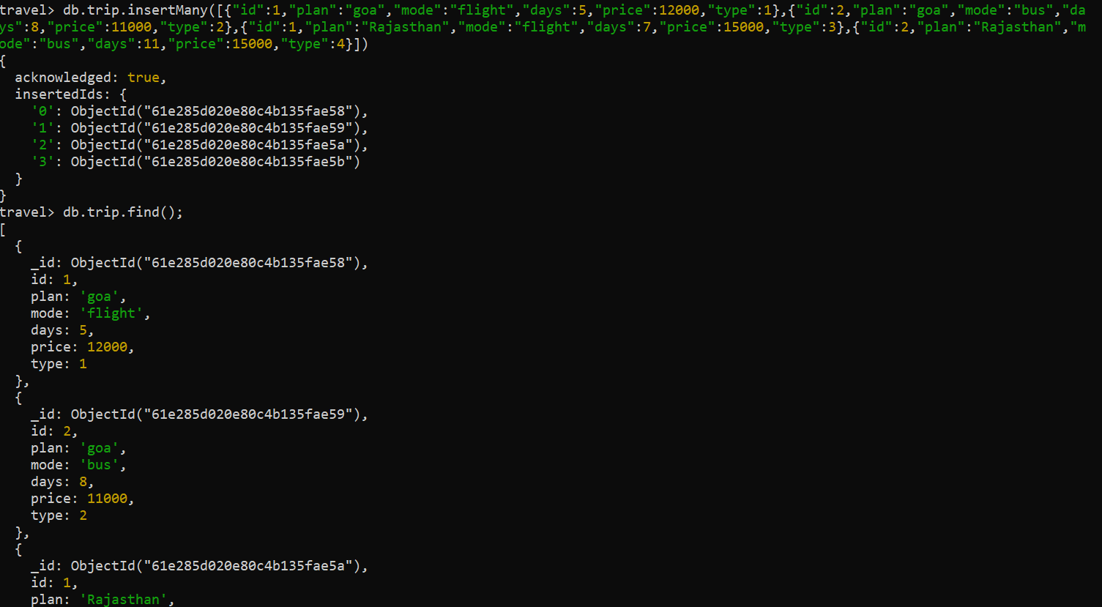

5)

db.trip.find({"mode":"bus"});

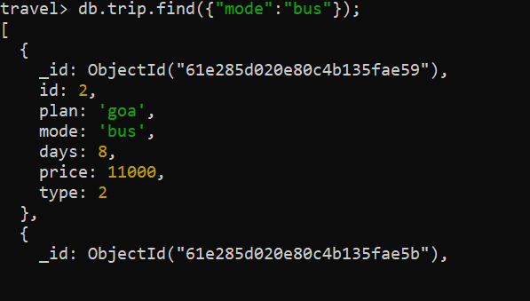

**Class Diagram**

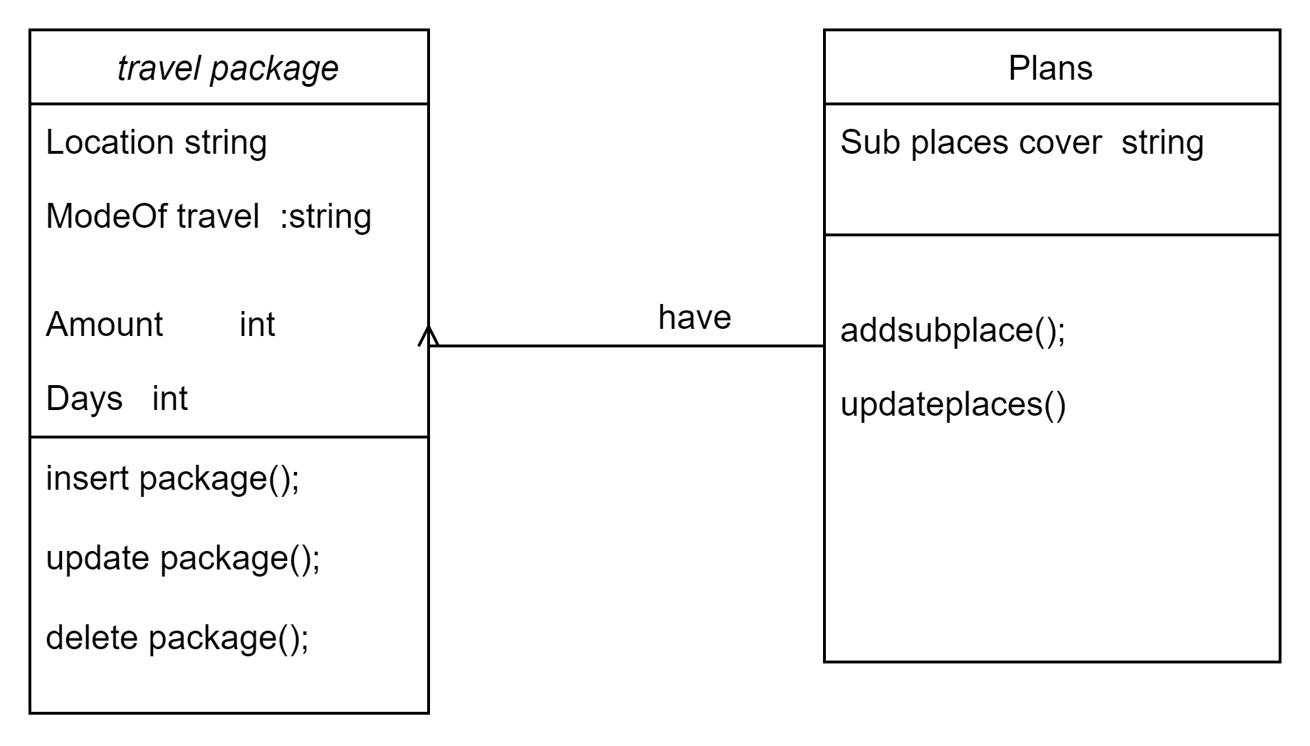

**Rest API**

| Description | For getting plans |
| --- | --- |
| Url | api.com/travels/plans |
| HTTP Method | GET |
| Data Passed |  |
| Data Received |  |
| Expected Response | 200 ok |
| Expected Error | 204 no content |

| Description | For creating a plan |
| --- | --- |
| Url | api.com/travels/plans |
| HTTP Method | POST |
| Data Passed |  |
| Data Received |  |
| Expected Response | 201 CREATED |
| Expected Error | 204 no content |

| Description | For updating a plan |
| --- | --- |
| Url | api.com/travels/plans/{plan_no} |
| HTTP Method | PUT |
| Data Passed |  |
| Data Received |  |
| Expected Response | 201 CREATED |
| Expected Error | 204 no Content |

| Description | For deleting plan |
| --- | --- |
| Url | api.com/travels/plans/{plan_no} |
| HTTP Method | DELETE |
| Data Passed |  |
| Data Received |  |
| Expected Response | 200 OK |
| Expected Error | 204 no content |

Front- end Page

